Optional HW 3 Log
ESAM 372-0
Rohan Krishnamurthi
11/6/2024

Correlation-plots of the log-transformed counts:
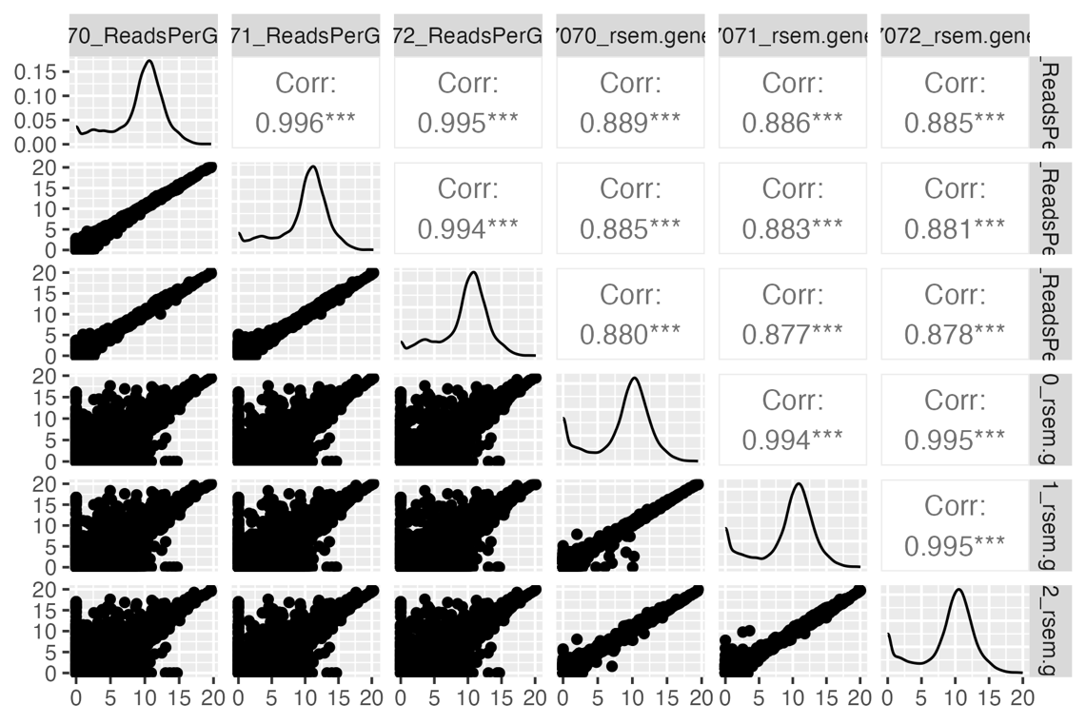
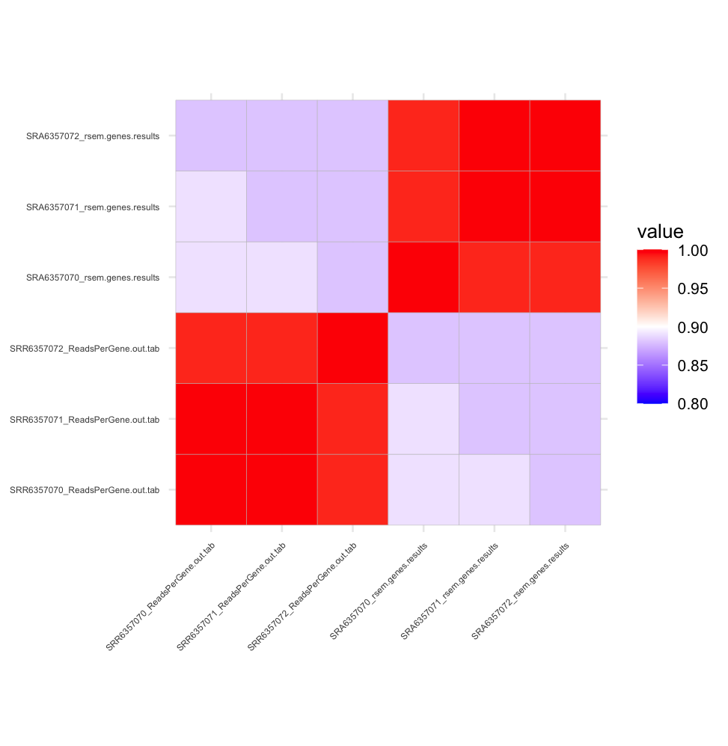

The correlation plots show that the STAR count files are highly correlated with each other, as they have correlation coefficients of at least 0.994. Similarly, the RSEM count files are highly correlated, with correlation coefficients of at least 0.994. The RSEM and STAR files are slightly less correlated with each other, as they have correlation coefficient values of 0.87-0.88. This indicates that for some genes, the counts are larger for STAR and smaller for RSEM, and vice versa.

Table of 25 genes in which STAR counts are most dominant:
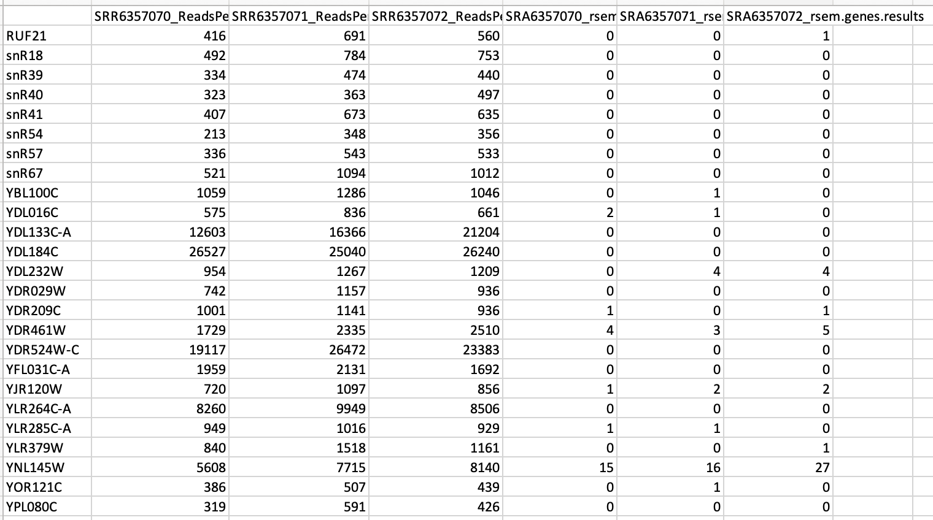

Table of 25 genes in which RSEM counts are most dominant:

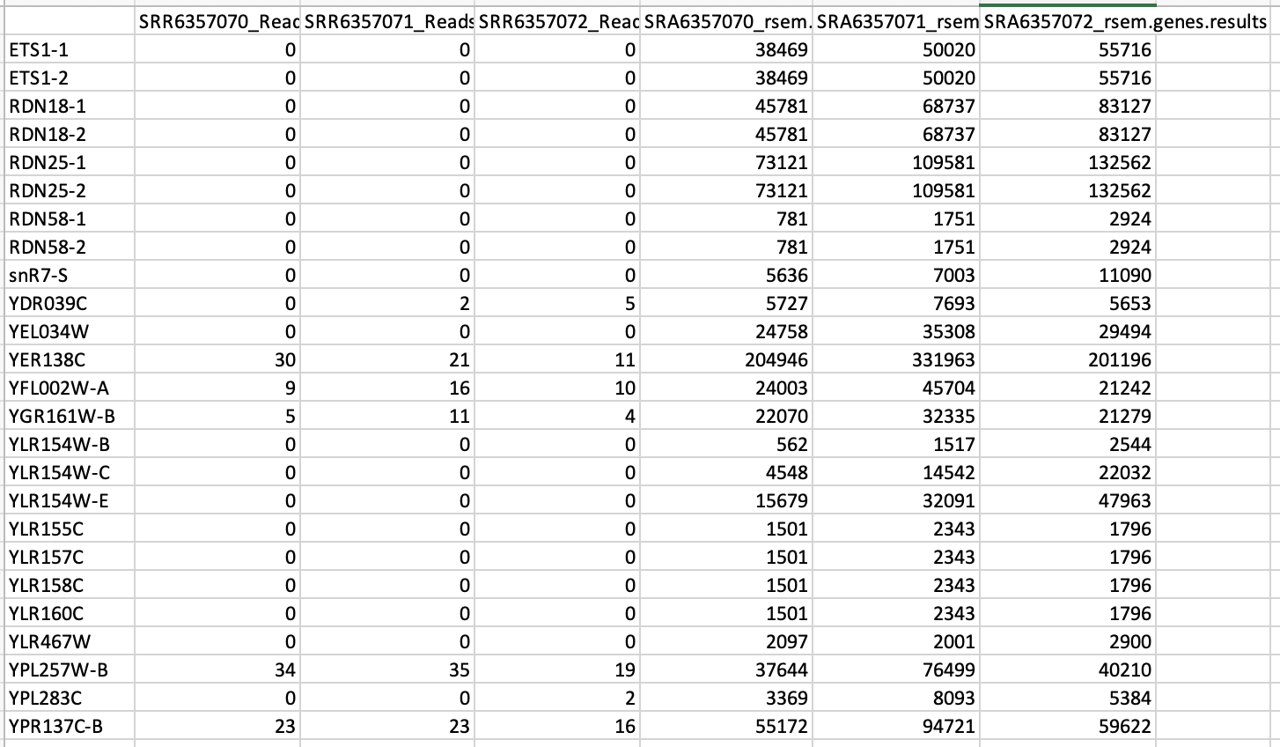

STAR Dominant IGV Images:

snR40 gene:
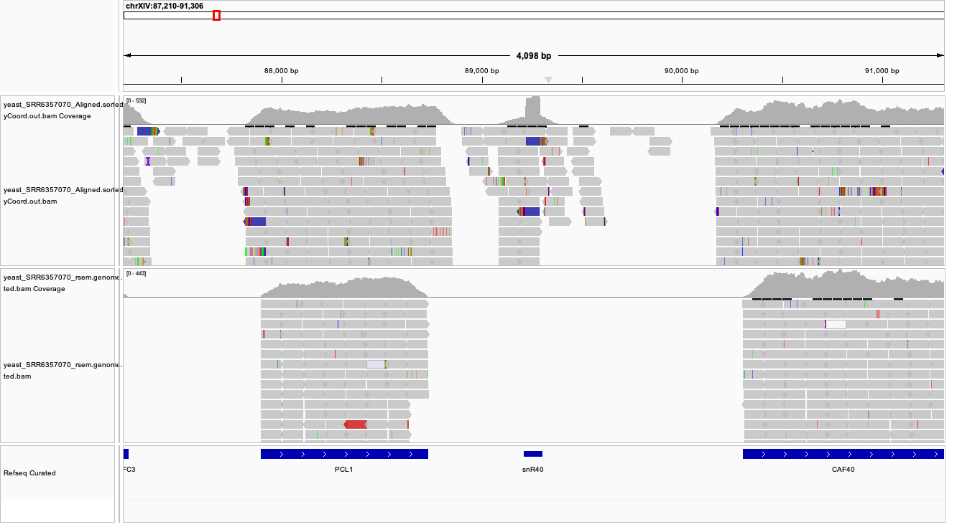

For the snR40 gene, the STAR tool counts many reads, while the RSEM method counts no reads at all. One hypothesis for why STAR counts far more reads is that these reads also map to other genes as well. While the STAR tool simply aligns all these reads to the snR40 gene and then counts them, the RSEM tool uses the Expectation Maximization (EM) algorithm to assign them to their most probable location, which in this case, is another gene. Another possible hypothesis is that these reads fall out of a coding region or are in introns, so RSEM doesn’t count them while STAR does count them.

YDR029W gene:
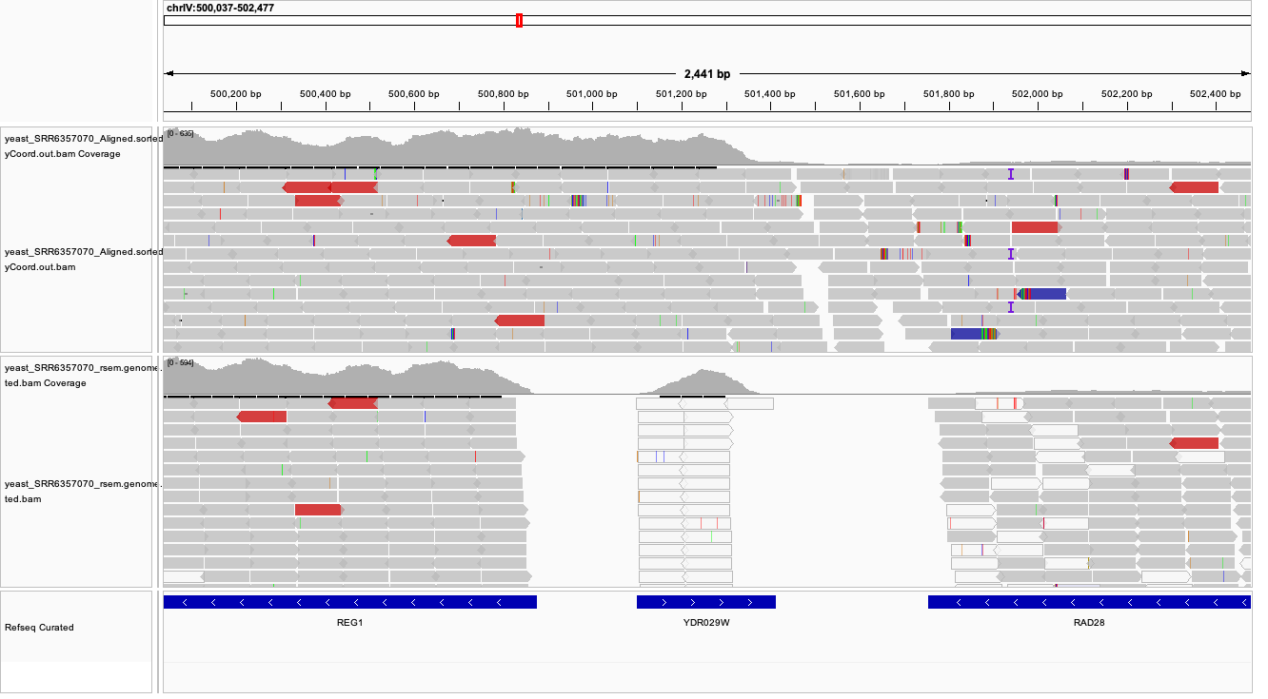

For the YDR029W, the STAR tool counts many reads, while the RSEM method counts no reads at all. Again, a possible explanation for this is that the reads map to multiple genes, and while STAR simply counts them as aligning to this gene, RSEM uses the EM algorithm to assign them to another gene. Another explanation is that these reads fall out of a coding region or are in introns, causing only STAR to count them.

YDR461W gene:
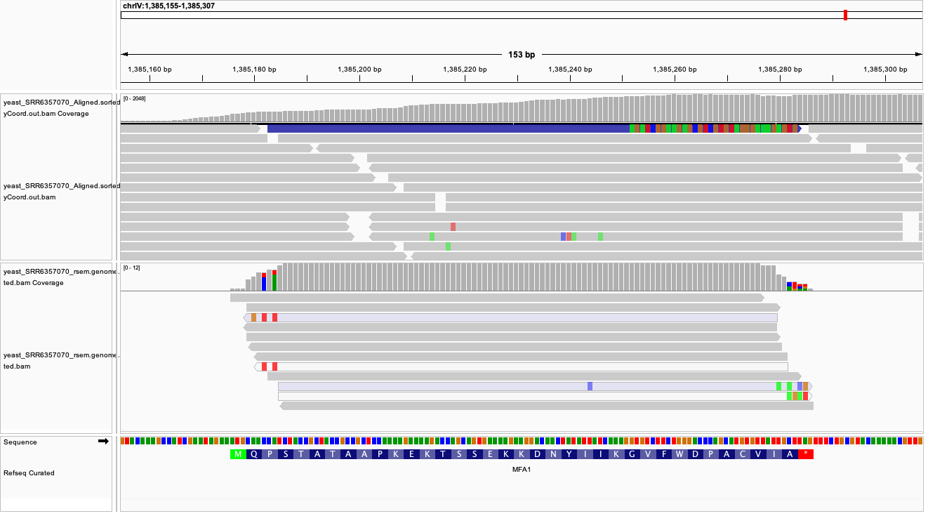

For the YDR461W gene, the RSEM tool counts a handful of reads, while the STAR tool counts many thousands of reads. Since this gene is composed of more nucleotides and is therefore longer, many reads are mapped to this gene compared to the previous two genes. In this gene, it is possible that many of the reads map to other genes as well. The STAR method made simply assign them to this gene and count them, while the RSEM method only assigns a fraction of the reads to this read following the EM algorithm. As a result, the STAR method counts far more reads.

RSEM Dominant IGV Images:
ETS1-1 gene:
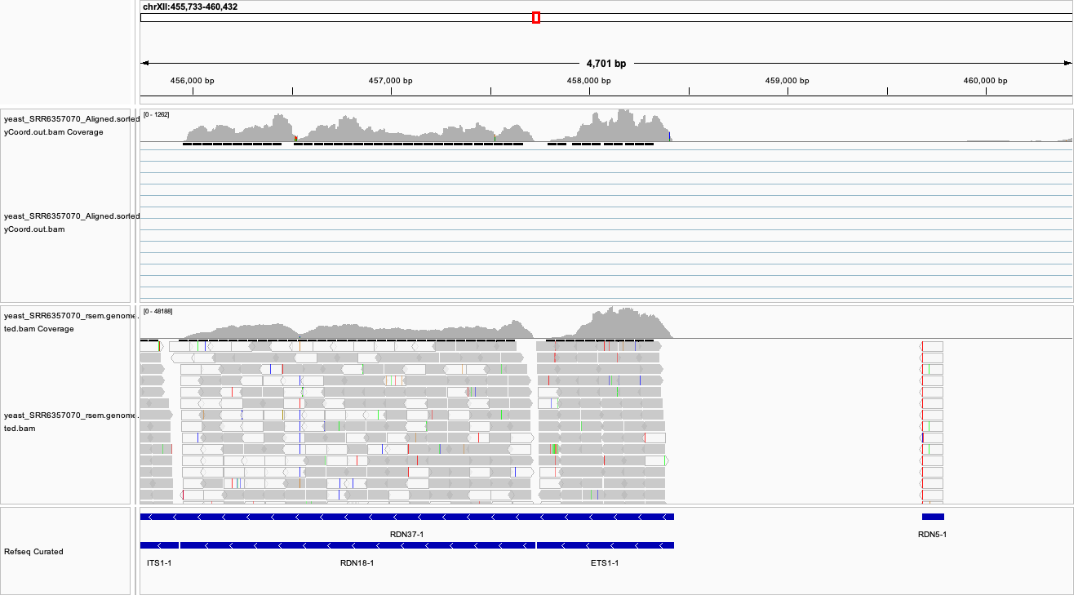

For the ETS1-1 gene, the STAR method maps no reads to the gene, while the RSEM method counts thousands of reads. In the image above, we can see the ETS1-1 gene aligning with the sequence for another gene. In STAR, only unique, non-overlapping reads count, so the STAR method doesn’t count any reads in this case. On the other hand, RSEM uses the EM algorithm to distribute ambiguous reads to potential gene candidates. Thus, the RSEM method counts several reads, while the STAR method does not.

YFL002W-A gene:
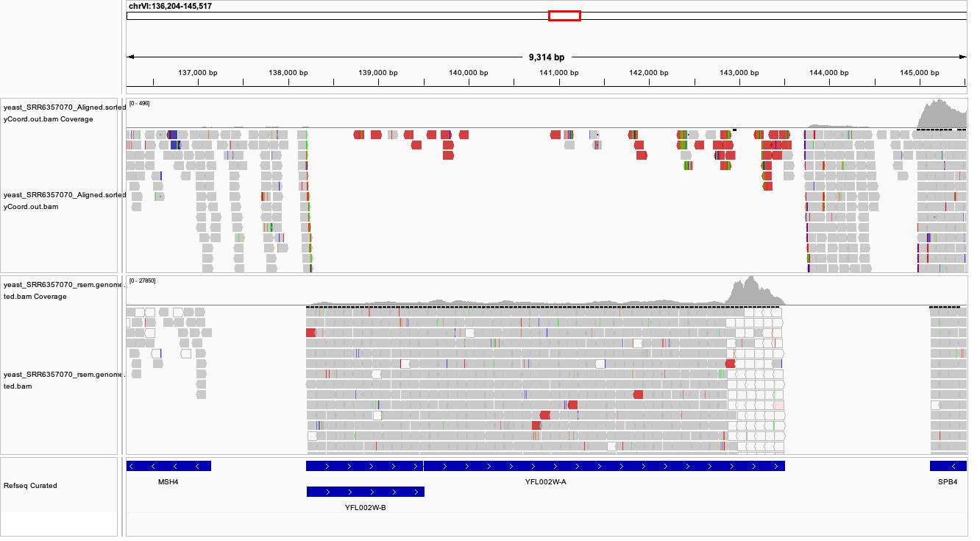

For the YFL002W-A gene, the STAR method only counts a handful of reads, while the RSEM method counts thousands of reads. One explanation for this is that the reads only partially align with the YFL002W-A. The STAR method would disregard these reads entirely, while the RSEM method would count a portion of them. Also, there is overlap of the YFL002W-A gene with the YFL002W-B. The STAR method may disregard the reads that overlap with the YFL002W-B gene as well, while the RSEM method may count some. Additionally, the gene may have alternative transcripts. RSEM counts reads at the transcript level before summing, causing it to overestimate the number of reads aligning to a gene in some cases.

YER138C gene:
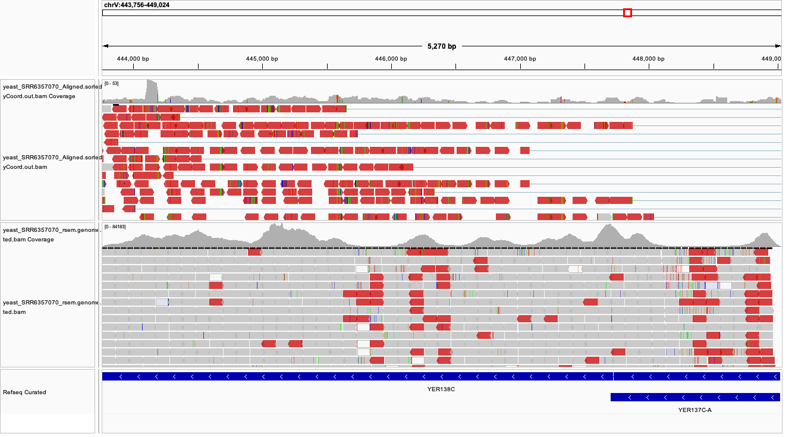

For the YER138C gene, again, the STAR method counts a handful of reads while the RSEM method counts thousands of reads. This gene is clearly longer than the previous two, so more reads align to it. One possible reason this discrepancy in tools occurs is due to the overlapping of the YER138C gene with the YER137C-A gene. Another reason is that the YER138C may have alternative transcript variants, causing RSEM to overestimate the true number of reads mapping to the gene. Another reason is that RSEM may assign some multi-mapping reads to this gene, while STAR excludes them entirely.

